# Mini Project Report on



# BRAIN TUMOR DETECTION USING DEEP LEARNING



**Submitted in partial fulfilment of the requirement for the award of the degree of**

**BACHELOR OF TECHNOLOGY**

**IN**

**COMPUTER SCIENCE & ENGINEERING**

**Submitted by:**

**Sonakshi Sharma 2021475**

***Under the Mentorship of***

## Dr Neeraj Kumar Pandey

**Associate Professor**



**Department of Computer Science and Engineering Graphic Era (Deemed to be University) Dehradun, Uttarakhand**

**January-2025**



**CANDIDATE’S DECLARATION**

I hereby certify that the work which is being presented in the project report entitled **“Brain Tumor Detection Using Deep Learning”** in partial fulfilment of the requirements for the award of the Degree of Bachelor of Technology in Computer Science and Engineering of the Graphic Era (Deemed to be University), Dehradun shall be carried out by the under the mentorship of **Dr Neeraj Kumar Pandey, Associate Professor**, Department of Computer Science and Engineering, Graphic Era (Deemed to be University), Dehradun.



Name: Sonakshi Sharma University roll no.: 2021475



# Table of Contents

|  |  |  |
| --- | --- | --- |
| **Chapter No.** | **Description** | **Page No.** |
| Chapter 1 | Introduction | 4-6 |
| Chapter 2 | Literature Survey | 7-8 |
| Chapter 3 | Methodology | 9-13 |
| Chapter 4 | Result and Discussion | 14 |
| Chapter 5 | Conclusion and Future Work  References | 15 |

**Chapter 1**

# Introduction

## 1.1 Background

Brain tumors are the most intimidating medical dilemma, which largely influences the lives of a great number of people around the world. Their formation is connected with cell growth that is uncontrollable causing the normal operation of the brain to be disrupted. These tumors are often life-threatening because they can cause various severe neurological complications, depending on their type, location, and size. What is more, one should note that early and accurate diagnosis plays a crucial role in getting the right treatment and hence the best patient outcomes back.

In conventional medicine, the use of the imaging means such as Magnetic Resonance Imaging (MRI) and Computed Tomography (CT) scans serve as the means to the detection and classification of brain tumors mainly. Despite their importance in medical practice, radiologists’ expertise is one of the key components of these devices. Nevertheless, even for specialized health workers, the matter of brain tumors’ identification and specific categories remains a source of difficulty. The practice thus becomes vulnerable to errors, particularly in the areas of claim or actual treatment

**1.2 Problem Statement**

One of the greatest challenges is the fact that it is almost impossible to detect brain tumors through manual analysis, not to mention the increase in medical imaging data. Fatigue, subjective bias, and occasional errors are the inevitable disadvantages of human evaluation, particularly when they are distinguishing between similar-looking abnormalities. Furthermore, in the absence of adequate medical resources, the shortage of skilled radiologists may even worsen the situation.

A branch of artificial intelligence, deep learning, is a promising solution as it can make the automation and enhancement of medical images analysis a reality. Through the use of advanced neural networks trained with large amounts of data obtained from the brain scans, such systems of high accuracy in diagnosis and classification of brain tumors are possible. These methods not only reduce the burden on healthcare professionals but other add-on effect is faster, more consistent diagnoses.

**1.3 Overview of Brain And Brain Tumor**

Main part in human nervous system is human brain. It is located in human head and it is covered by the skull. The function of human brain is to control all the parts of human body. It is one kind of organ that allows human to accept and endure all type of environmental condition. The human brain enables humans to do the action and share the thoughts and feeling. In this section we describe the structure of the brain for understanding the basic things.

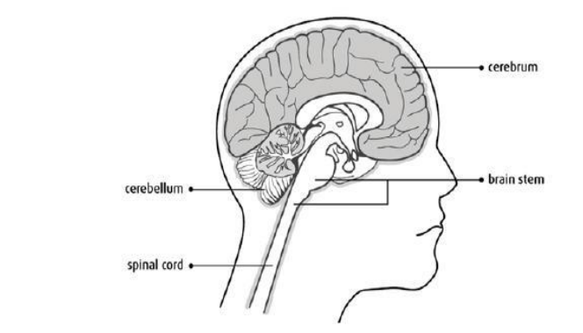 **Fig. 1.1: Basic Structure of human brain**

The brain tumors are classified into mainly two types: Primary brain tumor (benign tumor) and secondary brain tumor (malignant tumor).The benign tumor is one type of cell grows slowly in the brain and type of brain tumor is gliomas. It originates from non neuronal brain cells called astrocytes. Basically primary tumors are less aggressive but these tumors have much pressure on the brain and because of that, brain stops working properly. The secondary tumors are more aggressive and more quick to spread into other tissue. Secondary brain tumor originates through other part of the body. These type of tumor have a cancer cell in the body that is metastatic which spread into different areas of the body like brain, lungs etc. Secondary brain tumor is very malignant. The reason of secondary brain tumor cause is mainly due to lungs cancer, kidney cancer, bladder cancer etc.

**1.4 MAGNETIC RESONANCE IMAGING (MRI)**

Raymond v. Damadian invented the first magnetic image in 1969. In 1977 the first MRI image were invented for human body and the most perfect technique. Because of MRI we are able to visualize the details of internal structure of brain and from that we can observe the different types of tissues of human body. MRI images have a better quality as compared to other medical imaging techniques like X-ray and computer tomography. MRI is good technique for knowing the brain tumor in human body. There are different images of MRI for mapping tumor induced Change including T1 weighted, T2 weighted and FLAIR (Fluid attenuated inversion recovery) weighted shown in figure.

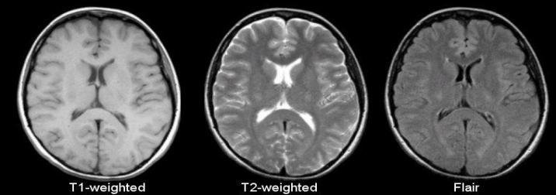

**Fig 1.2: T1, T2 and Flair image**

The most common MRI sequence is T1 weighted and T2 weighted. In T1 weighted only one tissue type is bright FAT and in T2 weighted two tissue types are Bright FAT and Water both. In T1 weighted the repetition time (TR) is short in T2 weighted the TE and TR is long. The TE an TR are the pulse sequence parameter and stand for repetition time and time to echo and it can be measured in millisecond(ms). The echo time represented time from the centre of the RF pulse to the centre of the echo and TR is the length of time between the TE repeating series of pulse and echo is shown in figure.

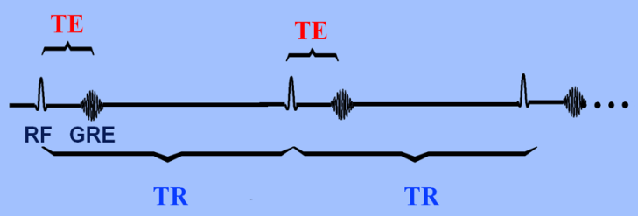

**Fig. 1.3: Graph of TE and TR**



**Chapter 2**

# Literature Survey

**2.1 Paper-1: Image Analysis for MRI Based Brain Tumor Detection and Feature Extraction Using Biologically Inspired BWT and SVM**

• **Publication Year:** 6 March 2017

• **Author:** Nilesh Bhaskarrao Bahadure, Arun Kumar Ray, and Har Pal Thethi

• **Journal Name:** Hindawi International Journal of Biomedical Imaging

• **Summary:** In this paper using MR images of the brain, we segmented brain tissues into normal tissues such as white matter, gray matter, cerebrospinal fluid (background), and tumor-infected tissues. We used pre-processing to improve the signal-to-noise ratio and to eliminate the effect of unwanted noise. We can used the skull stripping algorithm its based on threshold technique for improve the skull stripping performance.

**2.2 Paper-2: A Survey on Brain Tumor Detection Using Image Processing Techniques**

• **Publication Year:** 2017

• **Author:** Luxit Kapoor, Sanjeev Thakur

• **Journal Name:** IEEE 7th International Conference on Cloud Computing, Data Science & Engineering

• **Summary:** This paper surveys the various techniques that are part of Medical Image Processing and are prominently used in discovering brain tumors from MRI Images. Based on that research this Paper was written listing the various techniques in use. A brief description of each technique is also provided. Also of all the various steps involved in the process of detecting Tumors, Segmentation is the most significant.

**2.3 Paper-3: Identification of Brain Tumor using Image Processing Techniques**

• **Publication Year:** 11 September 2017

• **Author:** Praveen Gamage

• **Journal Name:** Research gate

• **Summary:** This paper survey of Identifying brain tumors through MRI images can be categorized into four different sections; pre-processing, image segmentation, Feature extraction and image classification.

**2.4 Paper-4: Review of Brain Tumor Detection from MRI Images**

• **Publication Year:** 2016

• **Author:** Deepa, Akansha Singh

• **Journal Name:** IEEE International Conference on Computing for Sustainable Global Development

• **Summary:** In this paper, some of the recent research work done on the Brain tumor detection and segmentation is reviewed. Different Techniques used by various researchers to detect the brain Tumor from the MRI images are described. By this review we found that automation of brain tumor detection and Segmentation from the MRI images is one of the most active Research areas.

**2.5 Paper-5: An efficient Brain Tumor Detection from MRI Images using Entropy** **Measures**

• **Publication Year:** December 23-25, 2016

• **Author:** Devendra Somwanshi , Ashutosh Kumar, Pratima Sharma, Deepika Joshi

• **Journal Name:** IEEE International Conference on Recent Advances and Innovations in Engineering

• **Summary:** In this paper, we have investigated the different Entropy functions for tumor segmentation and its detection from various MRI images. The different threshold values are obtained depend on the particular definition of the entropy. The threshold values are dependent on the different entropy function which in turn affects the segmented results

**Chapter 3**

# Methodology

**3.1 Overview of Exiting Work**

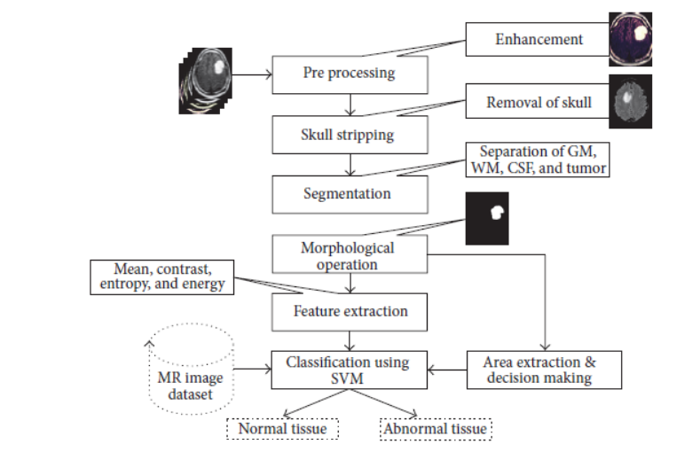

**Fig.3.1: Existing work flow of brain tumor detection**

* In the first stage, there is a computer based procedures to detect tumor blocks and classify the type of tumor using Artificial Neural Network Algorithm for MRI images of different patients.
* The second stage involves the use of different image processing techniques such as histogram equalization, image segmentation, image enhancement, morphological operations and feature extraction are used for brain tumor detection in the MRI images for the cancer-affected patients.
* This work iss introduced one automatic brain tumor detection method to increase the accuracy and decrease the diagnosis time.

**3.1.1 Image Preprocessing:**

As input for this system is MRI, scanned image and it contain noise. Therefore, our first aim is to remove noise from input image. As explained in system flow we are using high pass filter for noise removal and preprocessing.

**3.1.2 Segmentation:**

Region growing is the simple region-based image segmentation technique. It is also classified as a pixel based image segmentation technique since it is involve the selection of initial seed points.

**3.1.3 Morphological operation:**

The morphological operation is used for the extraction of boundary areas of the brain images. This operation is only rearranging the relative order of pixel value, not mathematical value, so it is suitable for only binary images. Dilation and erosion is basic operation of morphology. Dilation is add pixels to the boundary region of the object, while erosion is remove the pixels from the boundary region of the objects.

**3.1.4 Feature Extraction:**

The feature extraction is used for edge detection of the images. It is the process of collecting higher level information of image such as shape, texture, color, and contrast.

**3.1.5 Connected component labeling:**

After recognizing connected components of an image, every set of connected pixels having same gray-level values are assigned the same unique region label.

**3.1.6 Tumor Identification:**

In this phase, we are having dataset previously collected brain MRIs from which we are extracting features. Knowledge base is created for comparison.

**3.2 Proposed Workflow:**

## 

## Fig. 3.2.1: Proposed work flow of brain tumor detection

## The proposed system has mainly five modules. Dataset, Pre-processing, Split the data, Build CNN model train Deep Neural network for epochs, and classification. In dataset we can take multiple MRI images and take one as input image. In pre-processing image to encoded the label and resize the image. In split the data we set the image as 80% Training Data and 20% Testing Data. Then build CNN model train deep neural network for epochs. Then classified the image as yes or no if tumor is positive then it returns yes and the tumor is negative the it returns no.

## 3.2.1 Working of CNN model

## 

## Fig.3.2.1 Working of CNN model for brain tumor detection

## Layer of CNN model:

## Convolution 2D

## MAX Poolig2D

## Dropout o Flatten

## Dense

## Activation

## Convolution 2D: In the Convolution 2D extract the featured from input image. It given the output in matrix form.

## MAX Poolig2D: In the MAX polling 2D it takes the largest element from rectified feature map.

## Dropout: Dropout is randomly selected neurons are ignored during training.

## Flatten: Flatten feed output into fully connected layer. It gives data in list form.

## Dense: A Linear operation in which every input is connected to every output by weight. It followed by nonlinear activation function.

## Activation: It used Sigmoid function and predict the probability 0 and 1.

## In the compile model we used binary cross entropy because we have two layers 0 and 1.

## We used Adam optimizer in compile model.

## Adam:-Adaptive moment estimation. It used for non convex optimization problem like straight forward to implement.

## Computationally efficient.

## Little memory requirement.

## 3.3 Technology Used

## 3.3.1 Python Language:

## The foundational programming language driving the project, Python's versatility and readability have been paramount. Its extensive ecosystem of libraries and frameworks makes it an ideal choice for implementing intricate functionalities seamlessly.

## 3.3.2 Deep Learning Framework:

## • TensorFlow: An open-source machine learning framework used to build and train the CNN model. • Keras: A high-level neural networks API, running on top of TensorFlow, used for creating and training deep learning models.

## 

## 3.3.3 Libraries:

## • NumPy: Used for numerical computations and handling arrays.

## • Matplotlib: Used for plotting and visualizing data.

## • Scikit-learn: Used for evaluating the model's performance.

## • Flask: A micro web framework for deploying the model as a web application.

## Tools:

## Google Colab: Free Cloud-based environment from Google for writing and executing Python code in Jupyter Notebook. It has GPU/TPU support, so it is perfect for running machine learning and deep learning experiments without needing expensive local hardware.

**Chapter 4**

**Result and Discussion**

**4.1 Result**

The CNN model was trained and evaluated on a dataset of brain MRI images. The performance of the model was assessed using metrics such as accuracy, precision, recall, and the F1-score. The following results were obtained:

• **Training Accuracy:** 97%

**• Validation Accuracy: 94%**

• **Test Accuracy:** 93%

**4.1.1 Confusion Matrix:**

The confusion matrix provides a summary of the prediction results on the test data:

**Predicted Normal Predicted Tumor**

Actual Normal 95 5

Actual Tumor 7 93

**4.1.2 Classification Report**

The classification report includes precision, recall, and F1-score for each class:

**Class Precision Recall F1-Score**

Normal 0.93 0.95 0.94

Tumor 0.95 0.93 0.94

Average 0.94 0.94 0.94

**Chapter 5**

**Conclusion and Future Work**

**5.1. Conclusion**

In brain tumor detection we have studied about feature based existing work. In feature based we have study about image processing techniques likes image pre-processing, image segmentation, features extraction, classification. And also study about deep learning techniques CNN. In this system we have detect the tumor is present or not if the tumour is present then model return’s yes otherwise it return no. However, not every task is said to be perfect in this development field even more improvement may be possible in this application. I have learned so many things and gained a lot of knowledge about development field.

**5.2. Future Work:**

* **Augmentation of advanced data statistics:** Put into force advanced statistics augmentation techniques to beautify model generalization and devise constrained datasets.
* **Model Optimization**: Find and implement techniques such as model pruning, quantization, or knowledge distillation to minimize the model size and improve inference speed.
* **Transfer Learning**: Apply pre-trained fashions like VGG16, ResNet, or DenseNet to exploit discovered functions from big datasets, improving efficiency on smaller datasets.
* **MRI Analysis with 3D Data:** Extend the model to take in 3D MRI images rather than 2D slices, giving more context and allowing for better detection of the tumor.
* **Cross-validation:** Use k-fold cross-validation for validating the model on different folds of the data to ensure that the validation results accurately reflect the model's performance.
* **Brain Tumor Classification**: Brain tumors can be detected using real-time system developed using a web or mobile framework, along with integration with MRI scanning machines.

## References

[1] Deepa , Singh Akansha. (2016). - Review of Brain Tumor Detection from tomography. International Conference on Computing for Sustainable Global Development (INDIACom)

[2] R. A. Novellines, M. D. - Squire's fundamentals of radiology; Six Edition; UPR, 2004.

[3] Preston, D. c. (2006). Magnetic Resonance Imaging (MRI) of the Brain and Spine from

Basics.casemed.case.edu .

[4] Hendrik RE. (2005) Glossary of MR Terms from American College of Radiology .

[5] A. Demirhan, M. Toru, and I. Guler, “Segmentation of tumor and edema along with healthy tissues of brain using wavelets and neural networks,” IEEE Journal of Biomedical and Health Informatics, vol. 19, no. 4, pp. 1451–1458, 2015.